Vol. 1, Issue 07 SEPTEMBER 2002

The Scouting Scope
The aim of this UNOFFICIAL, resource-based newsletter is to give Scouters of every section a more focused look at some of Scouting’s more fun and challenging tasks that Leaders and program builders face in the 21st century. The information contained in this resource is from the amalgamated file of Jeff Melvin (chief-editor and contributor). I encourage you to follow the PPP rule with this resource
(Print, Promote, and Pass-along)

You will find that the information in this newsletter will have locally “Field Tested” ideas on GAMES, SONGS, PROGRAM ACTIVITIES, STORIES, MEETING PRAYERS, GROUP CHALLENGE, AND SCOUTING QUOTES that are prepared for use in your programs. If improper credits are given to a contribution, then please feel free to contact me at scouting@canada.com. Best of luck with you’re planning on the adventure trail.

FEATURE ARTICLE

RECRUITMENT…Are You Sharing Scoutings Unlimited Opportunities?

Virtually all Scouting areas require a constant inflow of new members to stay healthy and to continue an up-flow of membership. That's not necessarily a bad thing! Most members join Scouting to serve as a positive Leader and learn new skills while there son or daughter is taking advantage of the programs. Some will stay one there siblings are finished; some may not. A large percentage of the people who leave Scouting leave happy and say they might join again in the future.

Whose Job is it Anyways?

You may be a novice Scouter or a Amateur, regardless, it is every ones position to help promote Scouting values and to build membership. What are your plans build your Scouting image in your local or area community? Do you feel that it is someone else’s job? Many will say that “I run the program and that takes enough of my time” or “I am in charge of fundraising and not membership recruitment.” Well, if we all analyzed each job that we uphold in Scouting, in one way or another, we can ‘bend’ it around involving other non-members (with proper permissions) into the programs. In a sense, it is like asking for help while recruiting. How much more smartly-positive can you get?

On a section level, it is even easier to do your part without really trying. Take your group out amongst the community while doing your activities. Let people see that Scouting does exist. Try to make your activity eye appealing or an attention getter in order to attract others. Be sure that what ever activity that you are doing is rehearsed if need be to ensure the ideal turn out. Do ramblings like this several times through out the year. Most council offices provide posters and pamphlet information for your outings. Be sure to carry some extras to hand out when the times are appropriate. Challenge others to challenge themselves.

People can't join your club if they don't know you exist! There are multitudes of people waiting to join Scouting who "just haven't gotten around to it." Undoubtedly, there are people who are ready to join your group. They just need a little push in the form of a reminder. The following are some other ways that you and your committees can help build the image of true Scouting. Do it now, do it today recruit and share your experiences of Scouting with others.

- Many newspapers and company newsletters have calendar sections. In most cases you can submit your meeting time and location and be listed for free. If you live in a large metropolitan area, skip the big papers and target small weekly or semiweekly papers. You'll likely have more success.
- Many editors are starved for content. At your next meeting, take a photograph of someone in an adventurous or someone receiving an award. Then send the photo (with the negative if available or high resolution computer file) along with 300 - 500 words describing what's happening in the photo, the benefits of Scouting, your group meeting time and location, and an open invitation for guests.
- Your Scouting Groups can increase its visibility by sending out press releases on a variety of events ranging from rambles to weekend challenges to other community supports.
- Hand out a flyer to each house that you visit during your door to door advertising
- Bring a buddy meeting or outing (many do this) Bring the parents too.
- When you are going to make a presentation to a large group, take several volunteers with you both to talk about their own experiences and to help you deal with interested applicants.
- Get lists of other organizations in your area to see if they can help your recruitment effort by advertising your program, offering you time on their meeting agendas, distributing written information to their membership, posting notices on bulletin boards, etc. Churches are especially good at this.
- When trying to involve minorities as volunteers, find leaders in that community and recruit them to recruit their peers.
- Leader Recruitment: Every youth member that joins your group should also mean another adult volunteer to help. The quickest way to get more adult support is to get more youth members and the more adults you have the easier your job will become. Get your parents involved with all of your activities, don't give them the opportunity to be bystanders, remember this is a family program. It is usually a good idea to develop a list of positions that need to be filled by parents prior to your sign up night. This way you can constantly try to match every parent up with each of your needs.
- Make Recruitment a Year-Round Effort: Set goals for how many Cubs, Scouts, Explorers and Leaders you would like in your unit. Assign a membership coordinator within your committee who will work to carry out a year-round roundup plan. And keep trying new ideas. Just because something doesn't work for you the first time doesn't mean it's a bad idea, keep trying! Persistence always pays off in the end.

One of the most important steps that most people groups seems to innocently skip or miss is to let everyone know that they are running a membership recruitment campaign. Let everyone know what you are doing! Scouts Canada says it best…Bring On The Adventure!
" If the word QUIT is part of your vocabulary,
Then the word FINISH is likely not."

Games for Your Meeting

SWAMP CROSSING
Two equal teams line up facing each other across an open space. At each en of the teams line is a coffee can. The coffee cans contain identical objects as the cans across the field. The players are numbered from 1 to ? The leader calls out a number and an object. The player whose number is called must run across the field, find the object, place it in the can at the other end of the line, then run back to his own team’s side. The team to get it’s player back first gets a point, and the game continues. Objects can be added to the cans as the game progresses to make it more interesting.

SOMETHINGS FISHY
Each team is a fishing boat and its members are fish and fishermen. The first boy is the fish, while the second is the fisherman. The fisherman holds the line (popsicle stick with string attached), while the fish takes the loose end of the string. On 'GO', the fish runs to a designated point, stops, turns to face the boat, and the fisherman reels him in. The fisherman then becomes the fish, while the third boy on the team becomes the new fisherman. The object of the game is to land all the fish before the other team(s). When finished, the team sits in a straight line, each boy holding the shoulders of the boy in front of him, so they won't tip the boat.

NUMBERED CHAIRS
Players are seated in a circle and numbered off. There is a space in the circle that also gets a number. The number belongs to the chair, not the person sitting in it. Number One calls out another number. That number responds with another until someone calls the number of the space, or is unable to respond. The person who makes the mistake moves to the end of the line (highest numbered seat) and everyone moves up a space. The object of the game is to be Number One at the end of the game. Numbers should be called rapidly, with a special effort to unseat those at the top.

SHARK ATTACK
Equipment needed: Bandana for each Cub
Directions:
1. Appoint one Cub to be the shark.
2. In the shallow end of the swimming pool, have the other Cubs form a circle.
3. On your signal, have the "shark" swim around within the circle.
4. The Cubs feed the shark bandanas a few at a time while trying to stay away from the shark. *They need to stay within their area of the circle.
5. The shark gathers up the food as he stalks the Cubs.
6. At any given minute, the shark can "attack" a Cub.
7. If the shark touches a Cub, the Cub is out of the game.
8. Continue until only one Cub is left. He is the winner and the shark for the next game.

KEEP KOOL
Divide group into teams. Give each team a paper cup and a pail of water. Teams choose one member to go to a mark at the end of the course, give him a pop bottle and ask him to lie on his back holding the bottle, open end up, on his chest. On 'GO', the first youth of each team fills the cup, races to the team's pop bottle, and empties the cup into the bottle. He then lies down and becomes the bottle holder while the other player takes the cup and races back to tag off the next runner before going to the back of the line. This sequence is repeated until each player in turn has had a chance to play. The winner is the team whose bottle holder is first back into his starting position with the fullest pop bottle, or the team to fill the bottle first.

Together Everyone Achieves More!

Program Ideas and Hints

Comic Strip Jumble Quiz
See if you can unscramble the names of these cartoon favorites.
Tunseap
Ragah Het Lebrorih
Donblie
Ragdielf
Tebeel Yaleib

Answers:
Peanuts, Hagar the Horrible, Blondie, Garfield, Beetle Bailey

Right or Left Eyed?
The boys may be surprised to lean that they're either right-eyed or left-eyed, just as they are right- or left-handed. They can check by extending a finger toward a distant object while keeping both eyes open. Close the right eye. If the finger appears to jump, this means they are right-eyed. If it doesn't, they are left-eyed, since the left eye is dominant.

Prisoner's Escape Trick
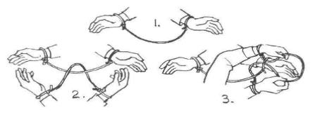
Tie a piece of string around wrists of your "victim" (one of the boys in your den). Loop another piece of string over your victim's wrist and tie it to your wrists. You are now locked together. Challenge victim to get away without breaking the string or untying a knot. When he gives up, show him how. Push the center of your string through the loop on the inside of your victim's wrist, bring this new loop back over his hand and draw it back through the wrist loop. You will be free. For double fun, tie two victims together in the same way.
Music Instrumentals

Bottlecap Tambourine
Find a strong Y-shaped branch. Get a dozen metal bottle caps and remove the rubber liners from the caps. Flatten the caps with a hammer, then use a nail to punch a small hole in the center of each cap. Thread the caps onto the wire and put the wire between the arms of the Y, tying the wire off on each end.

Hum Maker
Use a bathroom tissue tube and put a 4-inch square of waxed paper over one end. Secure with a rubber band. Poke a hole in the tube. Poke a hole in tube with a pencil as shown in picture. Hum through non-waxed paper end.
Straw Flute
Slit ½ inch on each side of one end of a straw. Cut finger holes in straw like picture. Mash straw flat on slit end. Place straw inside mouth so slit is behind your lips, Blow hard and use fingers over holes to make notes.

Walnut Maracas
Crack open a walnut and clean out the insides. Sand the walnut’s end so that you can insert a Popsicle stick and the halves will still go together. Put a few popcorn seeds, split peas, etc. inside one of the halves. Put glue on the edge of one of the halves and one end of the Popsicle stick. Put the walnut together with the stick in between the halves. Put a rubber band around the walnut to hold it together until the glue dries, several hours. You can decorate your maraca with paint or permanent marker or with clear varnish.

Wishbone Harp
Save that wishbone from the dinner chicken or turkey, for a tiny wishbone harp. String a small rubber band across the opening. Wind the band over several times if necessary. Use a pipe cleaner for the slide ring. You won’t get much sound if you pluck in the air. Rest the open end of your wishbone on a piece of wood or empty can and puck it gently. It should be fun to see how much melody you can coax from your miniature instrument.

Belt Drive
Merry-go-rounds, sewing machines, record players, fishing reels, washing machines, and bicycles: These are just a few of the many machines that turn, or rotate, as they work. All the different rotating par's inside a machine can be connected with a drive belt. As one part turns, it drags the belt around with it, carrying its turning motion to the other parts of the machine. How it Works. A drive belt runs round a series of pulleys to carry the force from one place to another. If the belt is going to work properly, there must be friction between it and the pulleys, so that the belt does not slip. If the belt is too slack, it will not grip. If it is too tight, it might break or twist the pulleys out of line. These whirling acrobats stand on thread spools connected by a belt made of ribbon.

Materials Needed:
Sandpaper
A wooden board
Glue and cardboard self-adhesive Velcro ribbon
Wooden dowel
Empty thread spools

1. Cut sandpaper into strips, and glue a strip around each of the thread spools. The rough surface of the sandpaper is needed to make some friction between the reels and the belt, This way, the belt will not slip.
2. Draw both the front and the back of each figure on a piece of cardboard as shown, leaving a space between front and back to make a base. Cut out the figures. Then fold and glue them so that they stand up.
3. Glue a figure onto each spool
4. Ask an adult, to help you cut the wooden dowel into a number of shorter dowel pegs. Smooth the ends of the pegs with sandpaper.
5. Drill holes into the baseboard. They should be just big enough for the dowel pegs to fit snugly into them.
6. Put the pegs into the holes, and then put a thread spool onto each peg. Check that every reel can turn freely on its peg.
7. Push a small piece of dowel into the gap between the center hole and the rim of one thread spool. This is the drive belt handle. You will use it to turn the drive belt.
8. Stretch a length of ribbon around the spools so that it touches them an. Use a piece of Velcro to join the ends of the ribbon Then you can adjust it so that it is not too tight and not too stack, and the figures will turn more smoothly.
Songs & Yells

Big Thumb: Hold out a hand at arms length, make a fist with the

Black Powder Cheer: Pretend to have black powder in your hand. Pour powder down the barrel. Stamp it down, raise the gun and fire saying, "Click, BANG!"

Boomalacka: Boomalacka, Boomalacka, Bow-wow-wow. Chingalacka, Chingalacka, Chow-chow-chow. Boomalcacka, Chingalacka, WOW ! WOW ! WOW !

Bouncing Ball: Using a golf ball (preferably) Have the group yell 'Pow' every time the ball hits the floor when dropped initially from an outstretched hand above the head, or thrown up.

Bravo (For an excellent performance): The cheer leader says: "That deserves a Bravo ! We'll do this in a circle." He then proceeds to have one end of the circle start with the 'BRR' sound and proceeds to point around the circle while they do the 'AVOOOO' sound. The sound level should rise as more of the circle comes in.

Bull Cheer: Make bull horns with fingers while shouting "El Toro, El Toro!"

Call the Hogs Yell: SOOOOOOOO EEEEEEEE, SOOOOOOOO, EEEEEEEE!!!!!!! PIG PIG PIG PIG!!!

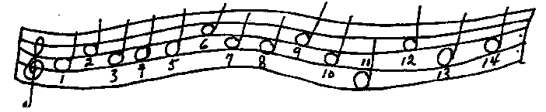
We’re all Together Again!
We're all together again, we're here, we're here,
We're all together again, we're here, we're here.
And who knows when, we'll be all together again?
Singing all together again, we're here, we're here!
One Dark Night
(Tune: Hot Time In the Old Town Tonight)
One dark night, when we were all in bed,
Old Lady Leary left a lantern in the shed.
And when the cow kicked it over,
She winked her eye and said:
“There’ll be a hot time in the old town tonight!”
FIRE, FIRE, FIRE!
One nights dark, when bed we all were in,
Old Lady Leary left a shed a lantern in.
And when the kick cowed it over,
She eyed her wink and said:
“There’ll be a time hot in the town old tonight!”
ARF! ARF! ARF!

Bring Back My Neighbours to Me
(Tune: My Bonnie)
Last night as I lay on my pillow,
Last night as I lay on my bed,
I stuck my feet out the window,
Next morning my neighbours were dead!
Bring back, bring back,
Oh bring back my neighbours to me to me.
Bring back, bring back,
Oh bring back my neighbours to me.

Mama don’t allow
Mama don’t allow no foot stomping round here.
Mama don’t allow no foot stomping round here.
I don’t care what Mama don’t allow,
I’m gonna foot stomp anyhow.
Repeat with the following: Foot stomping, hand clapping,
hooting and hollering.

Council Fire’s Light
Tune: ‘Til We Meet Again
By the blazing council fire’s light
We have met in comradeship tonight,
Round about the whispering trees
Guard our golden memories;
And so, before we close our eyes in sleep,
Let us pledge each other that we’ll keep
Scouting friendship strong and deep,
‘Till we meet again

Scouters’ 5 (meeting stories)

Are You Prepared?
Last night my family was returning home via Delta Airlines into Chicago's O'Hare Airport. We were delayed due to rough weather and were happy to be finally landing. Just as the ground was getting closer the plane shot up and banked hard. We had aborted the landing. In a few moments we were over Lake Michigan and circling. The Captain came on over the intercom and informed us (350 some passengers) that the nose gear had extended, however, there was no indication that it was in Locked position. They were in contact with maintenance and were working on the problem. I also heard him say that these planes have landed without nose gear, in such a tone of voice that we were reassured. He was Prepared.
I watched the Flight Attendants change their composure after being informed. They were readying themselves to do what they had to do. Were they Prepared? I wondered.

The passenger cabin lit up with conversation. Concerns, feelings and uncertainty. Were We Prepared?
Was I Prepared?

After a while the Captain came on and informed us that they had gone down and inspected the nose gear and it appeared Locked. We should now Prepare for landing.

The airport was shut down and the field was lit up with rescue equipment on either side of the runway. They Were Prepared.

Our landing was the softest I can remember.
Yes, I believe we were all nervous. But everyone did what they trained for. As Scouts we never know what the future holds for us. Are You Prepared?

John Nelson, Eagle Scout '68
ASM, Outings Co-Chair Troop 865 Mequon WI

The Sky is the Limit
Scouts; it wasn't long ago that we heard some people say: "The sky is the limit." That meant that a man could make anything of himself that he wanted...at least on earth. Well, that limit is now off. There is no limit to what you can aspire to do, either on earth or in space. Our astronauts have shown us that. Colonel "Buzz" Aldrin, the second man to walk on the moon, was a member of Troop 12 in Montclair, New Jersey. He said to a group of Scouts: "Set your goals high and settle for nothing less than accomplishment. Don't settle for mediocrity."

How well you perform as a man will depend on how you accept the new challenge which says, "The sky is not the limit." A Cub Scout who does his best in everything he undertakes now is preparing himself for that new challenge. If you want to aim for the stars, you must remember that you are building your launching pad right now by your willingness and initiative in every task you tackle.

Big Rocks
One day an expert in time management was speaking to a group of business students and, to drive home a point, used an illustration those students will never forget. As he stood in front of the group of high powered overachievers he said, "Okay, time for a quiz." The he pulled out a one-gallon, wide mouth mason jar and set it on the table in front of him. Then he produced about a dozen fist-sized rocks and carefully placed them, one at a time, into the jar. When the jar was filled to the top and no more rocks would fit inside, he asked, "Is this jar full?"
Everyone in the class said,"Yes."

Then he said, "Really?" He reached under the table and pulled out a bucket of gravel. Then he dumped some gravel in and shook the jar causing pieces of gravel to work themselves down into the space between the big rocks.

Then he asked the group once more, "Is the jar full?" By this time the class was on to him. "Probably not," one of them answered. "Good!" he replied. He reached under the table and brought out a bucket of sand. He started dumping the sand in the jar and it went into all of the spaces left between the rocks and the gravel. Once more he asked the question, "Is the jar full?"

"No!" the class shouted. Once again he said "Good." Then he grabbed a pitcher of water and began to pour it in until the jar was filled to the brim. Then he looked at the class and asked, "What is the point of this illustration?"

One eager beaver raised his hand and said, "The point is, no matter how full your schedule is, if you try really hard you can always fit some more things into it!"

"No," the speaker replied, "that's not the point. The truth this illustration teaches us is: if you don't put the big rocks in first, you'll never get them in at all." What are the 'big rocks' in your life? Time with your loved ones? Your faith, your education, your dreams?
A worthy cause? Teaching or mentoring others? Remember to put these BIG ROCKS in first or you'll never get them in at all.
So, tonight, or in the morning, when you are reflecting on this short story, ask yourself this question: What are the 'big rocks' in my life? Then, put those in the jar first...

The Obstacle in Our Path
In ancient times, a king had a boulder placed on a roadway. Then he hid himself and watched to see if anyone would remove the huge rock.
Some of the king's wealthiest merchants and courtiers came by and simply walked around it. Many loudly blamed the king for not keeping the roads clear, but none did anything about getting the big stone out of the way.

Then a peasant came along carrying a load of vegetables. On approaching the boulder, the peasant laid down his burden and tried to move the stone to the side of the road. After much pushing and straining, he finally succeeded.

As the peasant picked up his load of vegetables, he noticed a purse lying in the road where the boulder had been. The purse contained many gold coins and a note from the king indicating that the gold was for the person who removed the boulder from the roadway.

The peasant learned what many others never understand. Every obstacle presents an opportunity to improve one's condition.

SKITS (walk ons)

Artistic Genius
Cast: Three or more judges, Painters
Props: Canvasses, Easels (chairs can be used), Sign or banner announcing “Art Competition Today”
Scene: An art show, where judges are inspecting several canvasses on display. They comment on the brightness, color, technique, and brush strokes of each. They select one for first prize, and comment about the genius, imagination, and beauty of the picture.
The artist is summoned, and the winning picture is shown to him. The painter exclaims, “Oh my goodness, that got in by mistake! That is the canvas I clean my brushes on!”
Variations: To extend the skit and bring in more players, the judges can award third and second places to other artists with ridiculous names. You can add silly painting subject matters, etc., for the winners to describe their winning canvasses. Let your Scouts make the competing canvasses (Use newspaper, painted completely white. Let dry, allow Scouts to create masterpieces, then wrap over appropriate size piece of cardboard, and tape on the back.)

Snail Car
There was once a snail who was sick and tired of his reputation
for being so slow. He decided to get some fast wheels to make
up the difference. After shopping around a while, he decided
that the Datsun 240-Z was the car to get. So the snail goes to
the nearest Datsun dealer and says he wants to buy the 240-Z,
but he wants it repainted "240-S".
The dealer asks, "Why 'S'?"
The snail replies, "'S' stands for snail. I want everybody who
sees me roaring past to know whose driving."
Well, the dealer doesn't want to lose the unique opportunity to
sell a car to a snail, so he agrees to have the car repainted for
a small fee.
The snail gets his new car and spent the rest of his days roaring
happily down the highway at top speed. And whenever anyone would
see him zooming by, they'd say "Wow! Look at that S-car go!"

IF YOU CHASE TWO RABBITS BOTH WILL EXCAPE AND BE FREE.

-- Successories --

The Letter Fly
PROPS: Magnifying glass, fly swatter, bucket containing some bits of paper.

ANNO: Ladies and gentlemen, we are pleased to announce that we have the world famous specialist on camp flies with us this evening, Professor N. T. Mologist.

HOST: Professor Mologist, it is a great pleasure to have you at camp this evening. l understand you are going to tell us all about the type of flies we find at camp.

PROF: [heavy accent] Vy yess. Virst of all zer iss zee common House Fly. It flies all over zee house and zen lands on your food. Zis is a no good fly, 'cause it leaves cherms. You should swat zem. [runs around circle gently swatting at knees and shoulders]

HOST: Very interesting Professor, but what about some of the more unusual flies?

PROF: Vell, zere iss zee Horse Fly. You will recognize it because of its little hoofs and long bushy tail. 'Vait, I zink I zee vun over zere. [rushes with magnifying glass to one of the leaders] No, I vas wrong, dot vas a Boss Fly, zey hang around people who gif orders.

HOST: Come now Professor, you can't expect us to believe that flies have personalities?

PROF: No, you don't zink dot is zo? Vell ve will make a test. [selects Patrol Member and has him run around circle] Virst dis fly goes slowly zen it moves its little wings [boy flaps arms]. It is called a Circle Fly. Dis iss a very rare little beast vot always buzzes around leaders vith annoying questions.

CIRCLE FLY: [goes from leader to leader, repeating] When will, how soon, What if ???? [exits]

HOST: Our time is almost up Professor. What other strange fly can you tell us about?

PROF: I alvays tell about dis vun last. It is the Letter Fly.

HOST: The Letter Fly?

PROF: Yes, like vith a bucket of vater, you Let 'er Fly! [runs around circle with bucket flinging bits of paper on all, exits]

TID-BITS…

- Biting Insects. To make you less appealing to insects wear light coloured clothing. - Anon.
- Mosquito bites to minimize or avoid mosquito bites maintain high (but safe) levels of B vitamins (B complex). Flying insects will be turned off by the smell and taste of your blood. This is especially valuable when traveling in countries with Malaria, Dengue Fever and West Nile Virus.
- Insect Bites. To relieve an insect bite apply an ice pack or ice cube for 1- minutes. Let the skin dry, and then add an antihistamine or hydrocortisone cream.
- Rucksacks: When camping and walking where it may be wet, line the inside of your rucksack with a bin bag, and tie it to stop the contents getting wet.
- If suffering from heavy vomiting due to food poisoning/tummy bug/etc. fizzy drinks such as Coke and Pepsi help to re-hydrate and relieve the discomfort from vomiting
- Relieve Jelly Fish Stings: Coke can also be used to relieve the sting from Jelly Fish. All you have to do is pour the Coke over the sting.

<TID-BITS CONTINUED…>
- Common Cold: Take some fresh ginger and put it in a pot with a can of Coca Cola. Let it come to a boil and then cook on a low heat for a few minutes. Drink while warm. It will ease your cold symptoms!
- Pack rubbermaid or similar boxes with your event supplies. Not only does this keep things dry, but they become make-shift chairs when necessary.
- For fishing days, keep a small magnet in your tackle box. It's very handy for retrieving hooks, swivels, etc., when they fall into the grass or shallow water.
- Duct tape is handy for making minor repairs on tents, canoes, pants, and boots at camp. Instead of carrying a whole roll, wrap tape around a pen 10 to 15 times and carry it in your pack.
- To keep score papers, announcements, etc., on a clipboard from flapping in the wind outdoors, modify the board by sawing notches in the two sides of one of the lower corners. Hook a rubber band in the notches and snap it over the corner of the papers. The elastic holds down the papers but lets you remove them easily.
- The next time you want to tack up signs, posters, or pictures in an activity room, reinforce the corners to make them less likely to rip by covering them with transparent sticky tape before poking in the thumbtacks.
- When Cubs collect pine cones for crafts at camp, you can open them fully and remove sap by placing them on a foil-covered cookie sheet and setting them in a 250 degree F oven for awhile.
- To make an all-purpose hiking stick, try this idea. Cut 25 mm diameter plastic pipe to your preferred length. Put a plastic cap on one end and a removable curved piece or knob on the other. You can use it as you would any other walking stick, but there's a bonus. You can carry your fishing pole or important maps inside.

RECIPIES for Those
Who Eat…

Pigs in a Blanket
Ingredients: Hotdogs, Refrigerator biscuits, Cookie sheet
Directions:
1. Have an adult cut the hotdogs in half.
2. Let each Cub wrap biscuit dough around the hotdog half and pinch dough edges together.
3. Bake according to biscuit package directions.
4. Let cool and serve as a den snack.

Sewer Soda
1 qt. Chocolate chocolate chip ice cream
3/4 cup chocolate syrup
1 liter Club soda
Large spoon
4 tall glasses and spoons and straws
Let ice cream sit at room temperature until it is easy to scoop. Spoon ice cream into glasses until it is about halfway full. Pour or squeeze about 3 T. chocolate syrup into each glass. Slowly fill almost to the top with club soda and stir well with spoon. Serve with a straw and tall spoon for excavating those luscious brown lumps. Server 4 sewage slurpers. (Note: To make this slop thoroughly disgusting, plop an unwrapped tootsie roll into each glass.)
A Novel Way to Cook a Haut Dawg
A hot dog cooking idea that I'd never heard of before: Have each camper bring an empty carton of milk, 1-quart or 1/2 gallon. Place hot dog in bun. Wrap in tin foil. Put in milk carton, and place carton in fire circle or other safe burn spot. Light top of carton. By the time the carton is burnt to ground, THE HOT DOG IS COOKED!!
I have not tried this, but the Ranger said it worked and the dawg was nicely cooked, and the bun was lightly toasted. Sounds like a perfect 'just before leaving' meal -- NO CLEAN-UP!!
-- Thanks to Molly Orchardo

Corny Corn Bread Casserole
1 can cream corn
1 can regular corn
8 oz sour cream
1 stick margarine, melted
onion flakes
1 egg
1 package Jiffy corn bread muffin mix

Mix all together and pour into greased pan. Bake 350 to 375 degree oven until done. depending on size of pan determine length of baking time.
Notes:
Mom makes this in a deep casserole dish and bakes for an hour or so.
When I did this in the dutch oven, I skipped the onion flakes and didn't melt the butter first. It baked for about 40 minutes with 6 coals on the bottom and 20 on top.
A favorite with the boys, won 2nd place in the 1996 Wabuha District camporee cookoff. The boys judged adult division cooking, how did I win feeding them vegetables?
Thanks to Bill Randall, ASM Troop 7, Cedar Falls, IA

How a man plays a game, shows something of his character, how he loses shows all of it.
- Unknown -

Meeting Prayers
(Universal & Generic)

"An old Irish Blessing"
May the road rise to meet you,
May the wind always be at your back,
May the sun shine warm upon your face,
The rain fall soft upon your fields,
And until we meet again,
May god hold you in the palm of his hand.

Beaver Prayer
The air we breathe, the friends we meet,
The walk to use our eyes and feet,
The things around us make us say,
Thank you, God, for each new day!
-- From Scouting (U.K.) magazine

To Be Scoutlike
Grant to us, Lord, the spirit to think and to think and to do always such things as be Scoutlike; that we, who cannot do any good thing without You, may by You be enabled to live according to our Promise and Law; through Jesus Christ our Lord. Amen.
Prayers For Use In The Brotherhood of Scouts, p.59

A Closing Prayer
May the blessing of Almighty God rest upon us and upon all our work; may He give us Light to guide us, Courage to support us, and Love to unite us, now and evermore. Amen.
Prayers For Use In The Brotherhood of Scouts, p.91

God of the Universe
God of the universe, help us to see the hope of a better future for all your people. Help us to rise above our own likes and dislikes when there are more important things to consider, and to play our part in achieving some great good for our country and for the world. Amen.

Back to the Basics

Bring back one of true Scouting skills…lashing and rope work. Give these simple projects a try with your troop or company and send us a copy of it for publication!
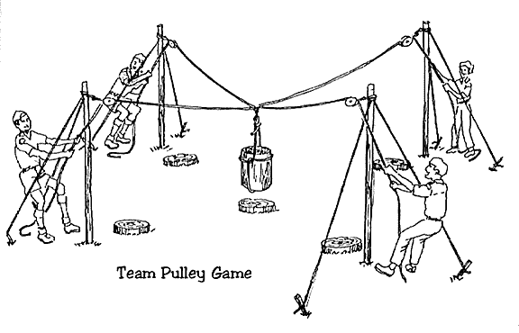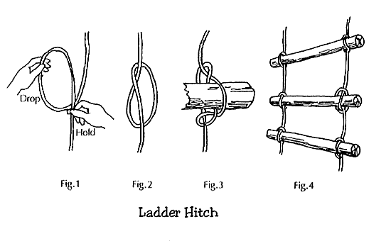
The Final Thoughts to
Take Home…

The best indices to a person's character are how he treats people who can't do him any good, and how he treats people who can't fight back.
- Abigail Van Buren
Be more concerned with your character than your reputation, because your character is what you really are, while your reputation is merely what others think you are.
- John Wooden
Ability may get you to the top, but it takes character to keep you there.
- John Wooden
"Hard work and togetherness. They go hand in hand. You need the hard work because it's such a tough atmosphere....to win week in and week out. You need togetherness because you don't always win,
and you ‘gotta hang tough together."
No change of circumstances can
repair a defect of character.
- Ralph Waldo Emerson

"There are two things to aim for in life :
The first is to get what you what, The second to enjoy it when you get it, Only the wisest of mankind
achieves the second. "

"If the word QUIT is part of your vocabulary,
Then the word FINISH is likely not."

REMEMBER
Special people always will be,
Ingrained in our heart and memory.
Look through the tears, the sorrow, the pain,
Reflect on the thoughts you want to retain.

Remember the love, the warm embrace,
Remember the touch, the smiling face.
Remember the person so gentle and kind,
Who always was caring in action and mind.

Always remember, never forget,
People live on in our heart.
And if you remember the person within,
Their spirit will never depart.
You are a shining star to Scouting!

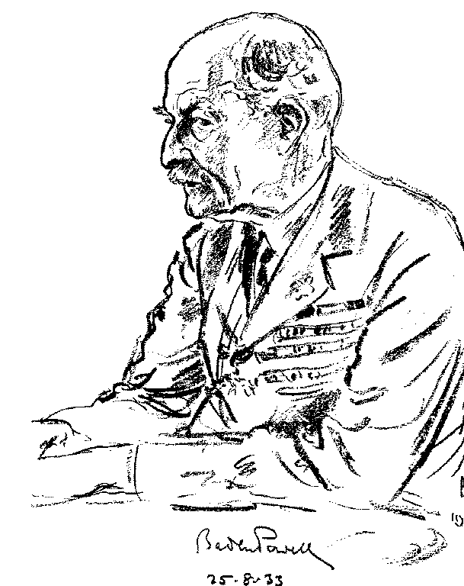
Please send your
ideas and hints to
“The Scout Scope”

SCOUTING@canada.com



